Culture

What is culture in the first place?

Culture is the identity of a specific group of people that determines them from the others.

Cordilleran Culture

We chose the cordilleran culture as our topic because it is one of the known cultures that we have here in the Philippines. There are different tribes in cordillera, but they somehow have resemblance on each other. Dialect, here in the cordillera region, many dialects are being used; Ilocano, Kankanaey, Ibaloi, Kalinga, Tagalog, etc. Cordilleran people are also known as “Igorots” or “People of the Mountains” and this is because they live in the mountain ranges of Cordillera.

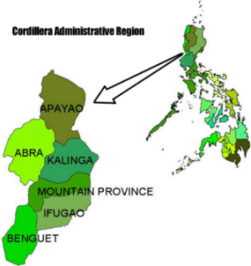 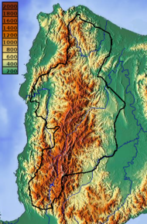

Figure I : Topographic map of CAR

Figure : Map of Cordillera Administrative Region (CAR)